International Economics: Theory and Policy, 12e (Krugman)
Chapter 14 Exchange Rates and the Foreign Exchange Market: An Asset Approach

14.1 Exchange Rates and International Transactions

1) The price of one currency in terms of another is called a(n) ________.
A) exchange rate
B) forward rate
C) effective rate
D) interest rate
E) trading rate
Answer: A
Difficulty: Easy
AACSB: Application of knowledge

2) How many dollars would it cost to buy an Edinburgh Woolen Mill sweater costing 50 British pounds if the exchange rate is 1.25 dollars per one British pound?
A) 50 dollars
B) 60 dollars
C) 70 dollars
D) 62.5 dollars
E) 40 British pounds
Answer: D
Difficulty: Easy
AACSB: Application of knowledge

3) How many dollars would it cost to buy an Edinburgh Woolen Mill sweater costing 50 British pounds if the exchange rate is 1.50 dollars per one British pound?
A) 50 dollars
B) 60 dollars
C) 70 dollars
D) 80 dollars
E) 75 dollars
Answer: E
Difficulty: Easy
AACSB: Application of knowledge

4) How many dollars would it cost to buy an Edinburgh Woolen Mill sweater costing 50 British pounds if the exchange rate is 1.80 dollars per one British pound?
A) 40 dollars
B) 90 dollars
C) 50 dollars
D) 100 dollars
E) 95 dollars
Answer: B
Difficulty: Easy
AACSB: Application of knowledge

5) The Japanese currency is called the
A) DM.
B) Yen.
C) Euro.
D) Dollar.
E) Pound.
Answer: B
Difficulty: Easy
AACSB: Application of knowledge

6) How many British pounds would it cost to buy a pair of American designer jeans costing $45 if the exchange rate is 1.50 dollars per British pound?
A) 440 British pounds
B) 20 British pounds
C) 30 British pounds
D) 35 British pounds
E) 25 British pounds
Answer: C
Difficulty: Easy
AACSB: Application of knowledge

7) How many British pounds would it cost to buy a pair of American designer jeans costing $45 if the exchange rate is 1.80 dollars per British pound?
A) 10 British pounds
B) 25 British pounds
C) 20 British pounds
D) 30 British pounds
E) 40 British pounds
Answer: B
Difficulty: Easy
AACSB: Application of knowledge

8) How many British pounds would it cost to buy a pair of American designer jeans costing $45 if the exchange rate is 2.00 dollars per British pound?
A) 22.5 British pounds
B) 32.5 British pounds
C) 12.5 British pounds
D) 40 British pounds
E) 30 British pounds
Answer: A
Difficulty: Easy
AACSB: Application of knowledge

9) How many British pounds would it cost to buy a pair of American designer jeans costing $45 if the exchange rate is 1.60 dollars per British pound?
A) 38.125 British pounds
B) 28.125 British pounds
C) 48.125 British pounds
D) 58.125 British pounds
E) 18.125 British pounds
Answer: B
Difficulty: Easy
AACSB: Application of knowledge

10) Exxon Mobil wants to pay €160,000 to a German supplier. They get an exchange rate quotation from its own commercial bank and instruct it to debit their dollar account and pay €160,000 to the supplier's German account. If the exchange rate quoted is $1.2 per euro, how much is debited to Exxon Mobil's account?
A) $192,000
B) $160,000
C) $172,000
D) $180,000
E) $150,000
Answer: A
Difficulty: Easy
AACSB: Application of knowledge

11) Total Wine & More wants to pay ¥500,000 to a Japanese supplier of sake and plum wine. They get an exchange rate quotation from its own commercial bank and instruct it to debit their dollar account and pay ¥500,000 to the supplier's Japanese account. If the exchange rate quoted is $0.0092 per Japanese yen, how much is debited to Total Wine & More's account?
A) $4,600
B) $1,150
C) $2,300
D) $9,200
E) $50,000
Answer: A
Difficulty: Easy
AACSB: Application of knowledge

12) What is the exchange rate between the dollar and the British pound if a pair of American jeans costs 50 dollars in New York and 100 Pounds in London?
A) 1.5 dollars per British pound
B) 0.5 dollars per British pound
C) 2.5 dollars per British pound
D) 3.5 dollars per British pound
E) 2 dollars per British pound
Answer: B
Difficulty: Easy
AACSB: Application of knowledge
13) What is the exchange rate between the dollar and the British pound if a pair of American jeans costs 60 dollars in New York and 30 Pounds in London?
A) 1.5 dollars per British pound
B) 0.5 dollars per British pound
C) 2.5 dollars per British pound
D) 3.5 dollars per British pound
E) 2 dollars per British pound
Answer: E
Difficulty: Easy
AACSB: Application of knowledge

14) What is the exchange rate between the British pound and the dollar if a pair of American jeans costs 40 dollars in New York and 20 Pounds in London?
A) 0.5 British pounds per U.S. dollar
B) 1.5 British pounds per U.S. dollar
C) 2.5 British pounds per U.S. dollar
D) 3.5 British pounds per U.S. dollar
E) 2 British pounds per U.S. dollar
Answer: A
Difficulty: Easy
AACSB: Application of knowledge

15) When a country's currency depreciates
A) foreigners find that its exports are more expensive, and domestic residents find that imports from abroad are more expensive.
B) foreigners find that its exports are more expensive, and domestic residents find that imports from abroad are cheaper.
C) foreigners find that its exports are cheaper; however, domestic residents are not affected.
D) foreigners are not affected, but domestic residents find that imports from abroad are more expensive.
E) foreigners find that its exports are cheaper and domestic residents find that imports from abroad are more expensive.
Answer: E
Difficulty: Easy
AACSB: Application of knowledge

16) When a country's currency appreciates
A) foreigners find that its exports are more expensive, and domestic residents find that imports from abroad are cheaper.
B) foreigners find that its exports are more expensive, and domestic residents find that imports from abroad are more expensive.
C) foreigners find that its exports are cheaper; however, domestic residents are not affected.
D) foreigners are not affected, but domestic residents find that imports from abroad are more expensive.
E) foreigners find that its exports are cheaper and domestic residents find that imports from abroad are more expensive.
Answer: A
Difficulty: Easy
AACSB: Application of knowledge

17) A depreciation of a country's currency
A) lowers the relative price of its exports and raises the relative price of its imports.
B) decreases the relative price of its exports and lowers the relative price of its imports.
C) raises the relative price of its exports and raises the relative price of its imports.
D) raises the relative price of its exports and lowers the relative price of its imports.
E) raises the relative price of its exports and does not affect the relative price of its imports.
Answer: A
Difficulty: Easy
AACSB: Application of knowledge

18) An appreciation of a country's currency
A) decreases the relative price of its exports and lowers the relative price of its imports.
B) raises the relative price of its exports and raises the relative price of its imports.
C) lowers the relative price of its exports and raises the relative price of its imports.
D) raises the relative price of its exports and lowers the relative price of its imports.
E) raises the relative price of its exports and does not affect the relative price of its imports.
Answer: D
Difficulty: Easy
AACSB: Application of knowledge

19) Which one of the following statements is the MOST accurate?
A) A depreciation of a country's currency makes its goods cheaper for foreigners.
B) A depreciation of a country's currency makes its goods more expensive for foreigners.
C) A depreciation of a country's currency makes its goods cheaper for its own residents.
D) A depreciation of a country's currency makes its goods cheaper.
E) An appreciation of a country's currency makes its goods more expensive.
Answer: A
Difficulty: Easy
AACSB: Application of knowledge

20) A(n) ________ of a nation's currency will cause imports to ________ and exports to ________, all other things held constant.
A) depreciation; increase; decrease
B) appreciation; decrease; increase
C) depreciation; decrease; increase
D) appreciation; increase; increase
E) depreciation; decrease; decrease
Answer: C
Difficulty: Moderate
AACSB: Application of knowledge

21) A(n) ________ of a nation's currency will cause imports to ________ and exports to ________, all other things held constant.
A) appreciation; increase; decrease
B) depreciation; decrease; decrease
C) depreciation; increase; decrease
D) appreciation; decrease; increase
E) depreciation; increase; increase
Answer: A
Difficulty: Moderate
AACSB: Application of knowledge

22) If the goods' money prices do NOT change, an appreciation of the dollar against the pound
A) makes British sweaters cheaper in terms of American jeans.
B) makes British sweaters more expensive in terms of American jeans.
C) doesn't change the relative price of sweaters and jeans.
D) makes American jeans cheaper in terms of British sweaters.
E) makes British jeans more expensive in Britain.
Answer: A
Difficulty: Moderate
AACSB: Application of knowledge

23) If the goods' money prices do NOT change, a depreciation of the dollar against the pound
A) makes British sweaters cheaper in terms of American jeans.
B) makes British sweaters more expensive in terms of American jeans.
C) makes American jeans more expensive in terms of British sweaters.
D) doesn't change the relative price of sweaters and jeans.
E) makes British jeans more expensive in Britain.
Answer: B
Difficulty: Moderate
AACSB: Application of knowledge

24) Compute how many dollars it would cost to buy an Edinburgh Woolen Mill sweater costing 50 British pounds for the following exchange rates.

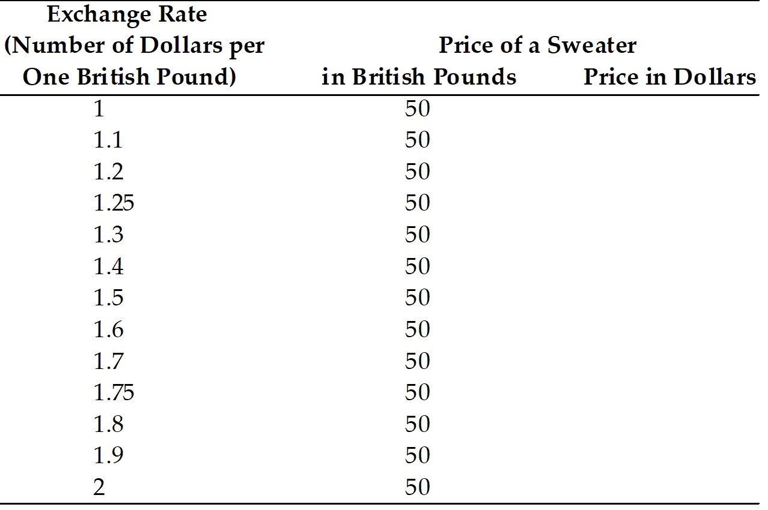

Answer:
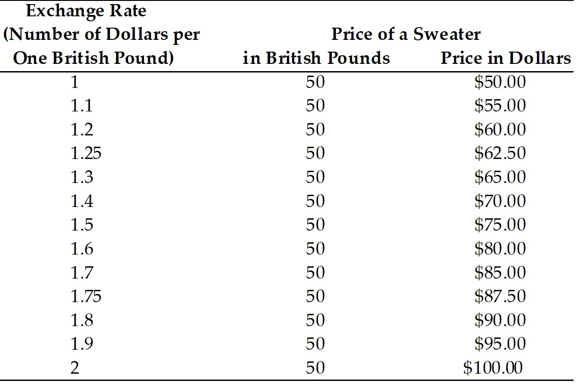

Difficulty: Easy
AACSB: Application of knowledge

25) Compute how many British pounds it would cost to buy a pair of American designer jeans costing $45.

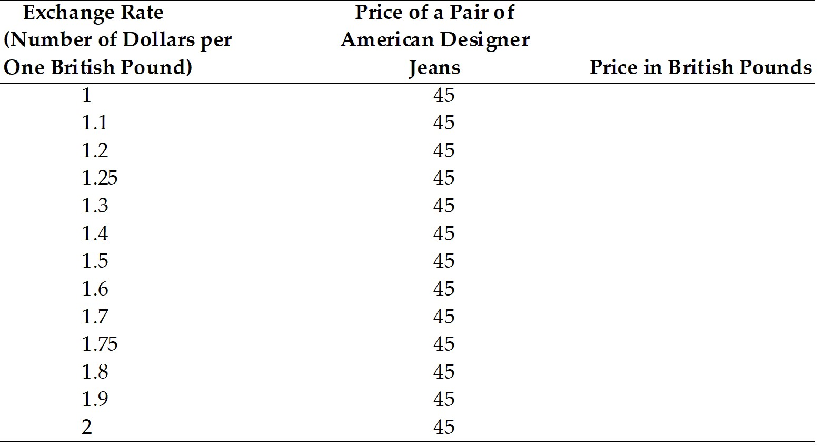

Answer:
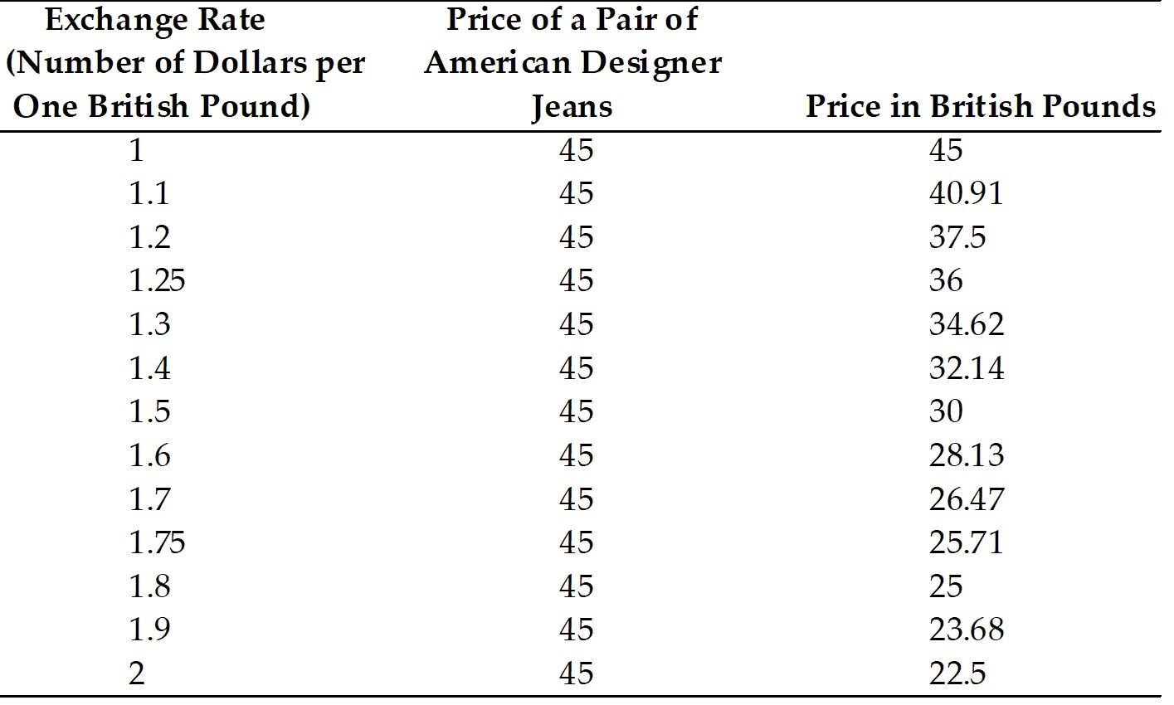

Difficulty: Easy
AACSB: Application of knowledge

26) Find the exchange rate between the dollar and the British pounds for the following cases.

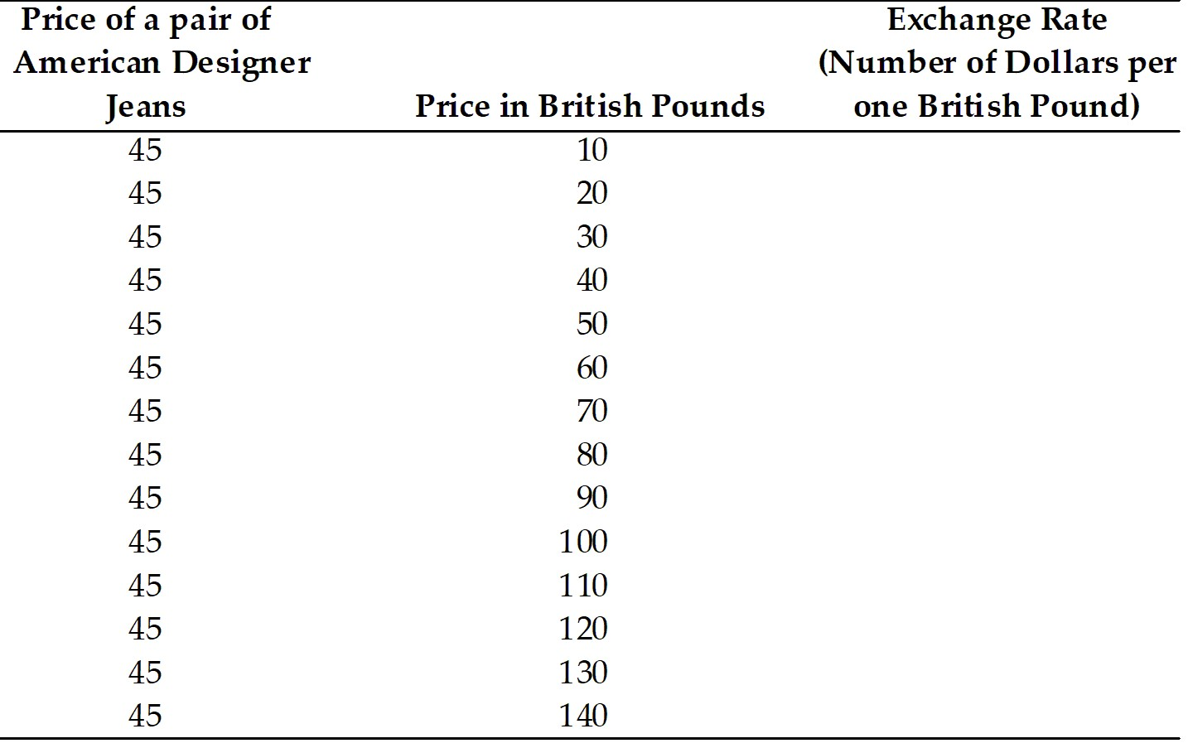
Answer:
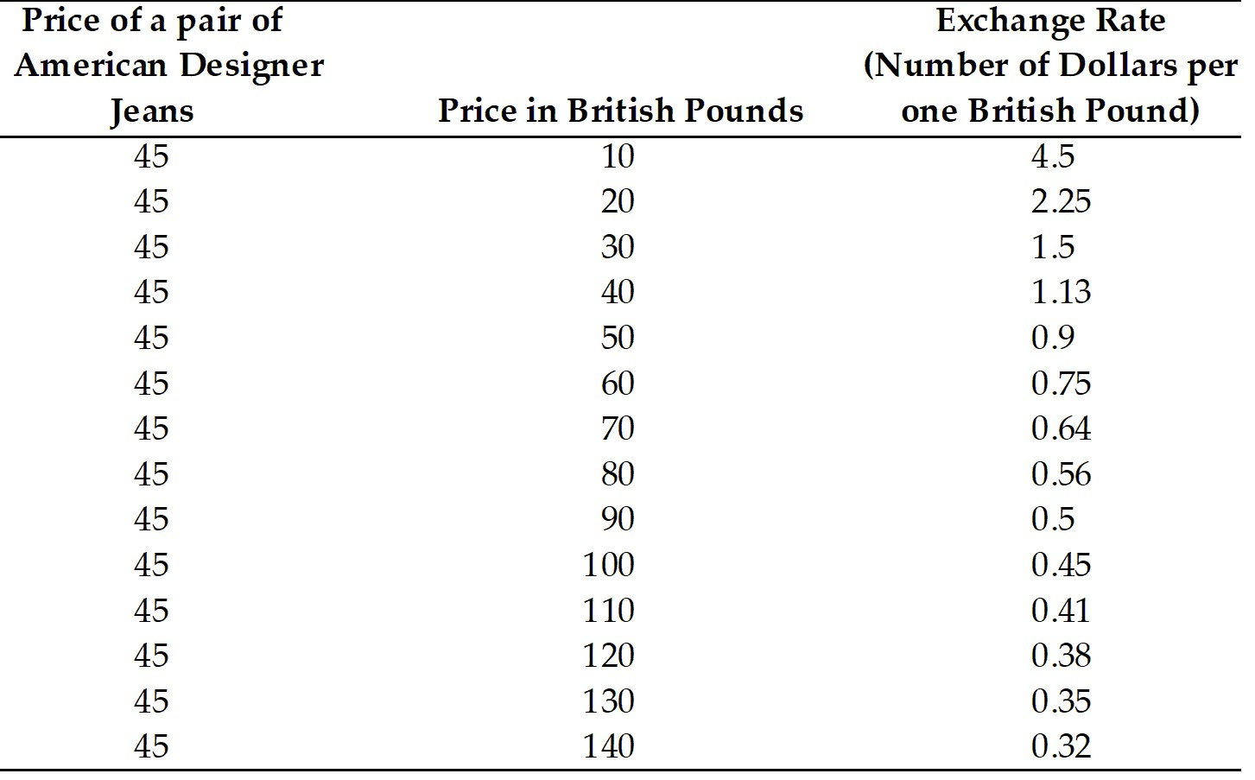

Difficulty: Easy
AACSB: Application of knowledge

14.2 The Foreign Exchange Market

1) The market in which households, firms, and financial institutions buy and sell foreign currencies to make international payments is called the
A) foreign exchange market.
B) currency market.
C) money market.
D) international market .
E) trading market.
Answer: A
Difficulty: Easy
AACSB: Application of knowledge

2) Which major actor is at the center of the foreign exchange market?
A) corporations
B) central banks
C) commercial banks
D) non-bank financial institutions
E) individual firms
Answer: C
Difficulty: Easy
AACSB: Application of knowledge

3) Which of the following is NOT a major actor in the foreign exchange market?
A) corporations
B) central banks
C) commercial banks
D) non-bank financial institutions
E) tourists
Answer: E
Difficulty: Easy
AACSB: Application of knowledge

4) Which of the following type of funds cater to wealthy individuals, are NOT bound by government regulations, and are actively traded in foreign exchange markets?
A) pension funds
B) mutual funds
C) hedge funds
D) exchange funds
Answer: C
Difficulty: Easy
AACSB: Application of knowledge

5) The largest trading of foreign exchange occurs in
A) New York.
B) London.
C) Tokyo.
D) Frankfurt.
E) Singapore.
Answer: B
Difficulty: Easy
AACSB: Application of knowledge

6) The action of arbitrage is
A) the process of buying a currency cheap and selling it dear.
B) the process of buying a currency dear and selling it cheap.
C) the process of buying and selling currency at the same price.
D) the process of selling currency at different prices in different markets.
E) the process of buying a currency and holding onto it to take it off the market.
Answer: A
Difficulty: Easy
AACSB: Application of knowledge

7) In 2019, about
A) 4.3 percent of foreign exchange transactions involved exchanges of foreign currencies for U.S. dollars.
B) 16.8 percent of foreign exchange transactions involved exchanges of foreign currencies for U.S. dollars.
C) 32.3 percent of foreign exchange transactions involved exchanges of foreign currencies for U.S. dollars.
D) 39 percent of foreign exchange transactions involved exchanges of foreign currencies for U.S. dollars.
E) 88.3 percent of foreign exchange transactions involved exchanges of foreign currencies for U.S. dollars.
Answer: E
Difficulty: Easy
AACSB: Application of knowledge

8) By April 2019
A) only about 0.9 percent of foreign exchange trades were against euros.
B) only about 4.3 percent of foreign exchange trades were against euros.
C) only about 32.3 percent of foreign exchange trades were against euros.
D) only about 39 percent of foreign exchange trades were against euros.
E) only about 88.3 percent of foreign exchange trades were against euros.
Answer: C
Difficulty: Easy
AACSB: Application of knowledge

9) Which of the following statements is TRUE about a vehicle currency?
A) It is widely used to denominate contracts made by parties who reside in the country that issues the vehicle currency.
B) The dollar is sometimes called a vehicle currency because of its pivotal role in many foreign exchange deals.
C) There is much skepticism that the euro will ever evolve into a vehicle currency on par with the dollar.
D) The pound sterling, once second only to the dollar as a key international currency, is beginning to rise in importance.
E) Vehicle currencies include nondeliverable currencies like the renminbi.
Answer: B
Difficulty: Easy
AACSB: Application of knowledge

10) The future date on which the currencies are actually exchanged is called what?
A) the value date
B) the spot exchange date
C) the two-day window
D) the commitment date
E) the forward exchange rate
Answer: A
Difficulty: Easy
AACSB: Application of knowledge

11) Which one of the following statements is the MOST accurate?
A) Spot exchange rates are always higher than forward exchange rates.
B) Spot exchange rates are always lower than forward exchange rates.
C) Spot exchange rates and forward exchange rates are always equal.
D) Spot exchange rates and forward exchange rates are equal when the value date and the date of the spot transaction are the same.
E) Spot exchange rates and forward exchange rates never move closely together.
Answer: D
Difficulty: Moderate
AACSB: Application of knowledge

12) Forward and spot exchange rates
A) are necessarily equal.
B) do not move closely together.
C) are always such that the forward exchange rate is higher.
D) move closely together and are equal on the value date when the value date and the date of the spot transaction are the same.
E) are unrelated to the value date.
Answer: D
Difficulty: Moderate
AACSB: Application of knowledge

13) The following is an example of Radio Shack hedging its foreign currency risk:
A) needing to pay 9,000 yen per radio to its suppliers in a month, Radio Shack makes a forward-exchange deal to buy yen.
B) needing to pay 9,000 yen per radio to its suppliers in a month, Radio Shack makes a forward-exchange deal to sell yen.
C) needing to pay 9,000 yen per radio to its suppliers in a month, Radio Shack buys yen at a spot-exchange 1 month from now.
D) needing to pay 9,000 yen per radio to its suppliers in a month, Radio Shack sells yen at a spot-exchange 1 month from now.
E) needing to pay 9,000 yen per radio to its suppliers in a month, Radio Shack sells yen in a forward-exchange deal.
Answer: A
Difficulty: Easy
AACSB: Application of knowledge

14) A foreign exchange swap
A) is a spot sale of a currency.
B) is a forward repurchase of the currency.
C) is a spot sale of a currency combined with a forward repurchase of the currency.
D) is a spot sale of a currency combined with a forward sale of the currency.
E) make up a negligible proportion of all foreign exchange trading.
Answer: C
Difficulty: Easy
AACSB: Application of knowledge

15) Which of the following is NOT an example of a financial derivative?
A) forwards
B) bonds
C) swaps
D) futures
E) options
Answer: B
Difficulty: Easy
AACSB: Application of knowledge

16) Futures contracts differ from forward contracts in that
A) future contracts ensures you will receive a certain amount of foreign currency at a specified future date.
B) future contracts bind you into your end of the deal.
C) future contracts allow you to sell your contract on an organized futures exchange.
D) future contracts are a disadvantage if your views about the future spot exchange rate are to change.
E) futures contracts don't allow you to realize a profit or a loss right away.
Answer: C
Difficulty: Moderate
AACSB: Application of knowledge

17) Who are the major participants in the foreign exchange market?
Answer:
(1) Commercial banks
(2) Corporations
(3) Nonbank financial institutions
(4) Central banks
Difficulty: Easy
AACSB: Application of knowledge

18) Explain what is a "vehicle currency." Why is the U.S. dollar considered a vehicle currency?
Answer: A vehicle currency is one that is widely used to denominate international contracts made by parties who do not reside in the country that issues the vehicle currency. Since in 2004, nearly 90 percent of foreign exchange transactions involve exchanges of foreign currencies for U.S. dollars; therefore, it is considered a vehicle currency.
Difficulty: Moderate
AACSB: Application of knowledge

19) Explain the purpose of the following figure.
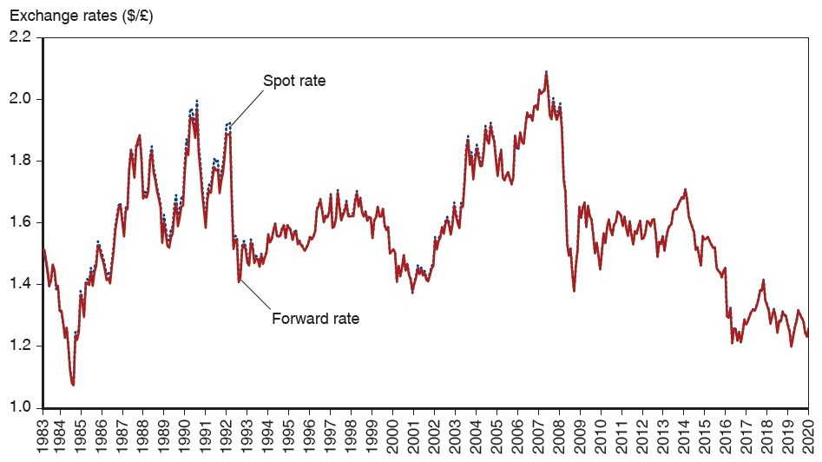
Answer: To show that spot and forward exchange rates move closely together.
Difficulty: Moderate
AACSB: Application of knowledge

14.3 The Demand for Foreign Currency Assets

1) What is the expected dollar rate of return on euro deposits if today's exchange rate is $1.10 per euro, next year's expected exchange rate is $1.165 per euro, the dollar interest rate is 10%, and the euro interest rate is 5%?
A) 10%
B) 11%
C) -1%
D) 0%
E) 15%
Answer: B
Difficulty: Moderate
AACSB: Application of knowledge

2) What is the expected dollar rate of return on dollar deposits if today's exchange rate is $1.10 per euro, next year's expected exchange rate is $1.165 per euro, the dollar interest rate is 10%, and the euro interest rate is 5%?
A) 10%
B) 11%
C) -1%
D) 0%
E) 15%
Answer: A
Difficulty: Easy
AACSB: Application of knowledge

3) What is the expected dollar rate of return on euro deposits if today's exchange rate is $1.167 per euro, next year's expected exchange rate is $1.10 per euro, the dollar interest rate is 10%, and the euro interest rate is 5%?
A) 10%
B) 11%
C) -1%
D) 0%
Answer: C
Difficulty: Moderate
AACSB: Application of knowledge

4) Which one of the following statements is the MOST accurate?
A) Since dollar and yen interest rates are measured in comparable terms, they can move quite differently over time.
B) Since dollar and yen interest rates are not measured in comparable terms, they can move quite differently over time.
C) Since dollar and yen interest rates are measured in comparable terms, they move quite the same over time.
D) Since dollar and yen interest rates are measured in comparable terms, they still move quite differently over time.
E) Since dollar and yen interest rates are so similar, they move quite the same way over time.
Answer: B
Difficulty: Easy
AACSB: Application of knowledge

5) The dollar rate of return on euro deposits is
A) approximately the euro interest rate plus the rate of depreciation of the dollar against the euro.
B) approximately the euro interest rate minus the rate of depreciation of the dollar against the euro.
C) the euro interest rate minus the rate of inflation against the euro.
D) the rate of appreciation of the dollar against the euro.
E) the euro interest rate plus the rate of inflation against the euro.
Answer: A
Difficulty: Easy
AACSB: Application of knowledge

6) If the dollar interest rate is 10 percent and the euro interest rate is 6 percent, then an investor should
A) invest only in dollars.
B) invest only in euros.
C) be indifferent between dollars and euros.
D) invest only in dollars if the exchange rate is expected to remain constant.
E) invest only in euros if the exchange rate is expected to remain constant.
Answer: D
Difficulty: Easy
AACSB: Application of knowledge

7) If the dollar interest rate is 5 percent and the euro interest rate is 3 percent, then an investor should
A) invest only in dollars if the exchange rate is expected to remain constant.
B) invest only in dollars.
C) invest only in euros.
D) be indifferent between dollars and euros.
E) invest only in euros if the exchange rate is expected to remain constant.
Answer: A
Difficulty: Easy
AACSB: Application of knowledge

8) If the dollar interest rate is 4 percent, the euro interest rate is 6 percent, then
A) an investor should invest only in dollars.
B) an investor should invest only in euros.
C) an investor should be indifferent between dollars and euros.
D) invest only in dollars if the exchange rate is expected to remain constant.
E) invest only in euros if the exchange rate is expected to remain constant.
Answer: E
Difficulty: Easy
AACSB: Application of knowledge

9) If the dollar interest rate is 5 percent, the euro interest rate is 10 percent, then
A) invest only in euros if the exchange rate is expected to remain constant.
B) an investor should invest only in dollars.
C) an investor should invest only in euros.
D) an investor should be indifferent between dollars and euros.
E) invest only in dollars if the exchange rate is expected to remain constant.
Answer: A
Difficulty: Easy
AACSB: Application of knowledge

10) If the dollar interest rate is 10 percent, the euro interest rate is 6 percent, then
A) an investor should invest only in dollars if the expected dollar depreciation against the euro is 4 percent.
B) an investor should invest only in euros if the expected dollar depreciation against the euro is 4 percent.
C) an investor should be indifferent between dollars and euros if the expected dollar depreciation against the euro is 4 percent.
D) an investor should invest only in dollars.
E) an investor should invest only in euros.
Answer: C
Difficulty: Moderate
AACSB: Application of knowledge

11) If the dollar interest rate is 10 percent and the euro interest rate is 6 percent, then
A) an investor should invest only in dollars if the expected dollar depreciation against the euro is 8 percent.
B) an investor should invest only in euros if the expected dollar depreciation against the euro is 8 percent.
C) an investor should be indifferent between dollars and euros if the expected dollar depreciation against the euro is 8 percent.
D) an investor should invest only in dollars.
E) an investor should invest only in euros.
Answer: B
Difficulty: Moderate
AACSB: Application of knowledge

12) If the dollar interest rate is 10 percent, the euro interest rate is 12 percent, then
A) an investor should invest only in dollars if the expected dollar appreciation against the euro is 4 percent.
B) an investor should invest only in euros if the expected dollar appreciation against the euro is 4 percent.
C) an investor should be indifferent between dollars and euros if the expected dollar appreciation against the euro is 4 percent.
D) an investor should invest only in dollars.
E) an investor should invest only in euros.
Answer: A
Difficulty: Moderate
AACSB: Application of knowledge

13) What are the three factors that affect the demand for foreign currency?
Answer: The three factors that affect the demand for foreign currency are expected return, risk and liquidity.
Difficulty: Moderate
AACSB: Application of knowledge

14) Explain risk and liquidity of assets.
Answer: Risk is the variability an asset contributes to a savers' wealth. An asset's real return can be unpredictable and savers dislike this uncertainty if the return fluctuates widely. Liquidity refers to the ease with which an asset can be sold or exchanged for goods. Cash is the most liquid of assets because it is always acceptable at face value as payment for goods or other assets. Thus, savers consider an asset's liquidity and its expected return and risk in deciding how much of it to hold.
Difficulty: Moderate
AACSB: Application of knowledge

15) Explain the purpose of the following figure 14-2 from the text in the context of the interest rates on the dollar and the Japanese Yen between 1978 and 2020.
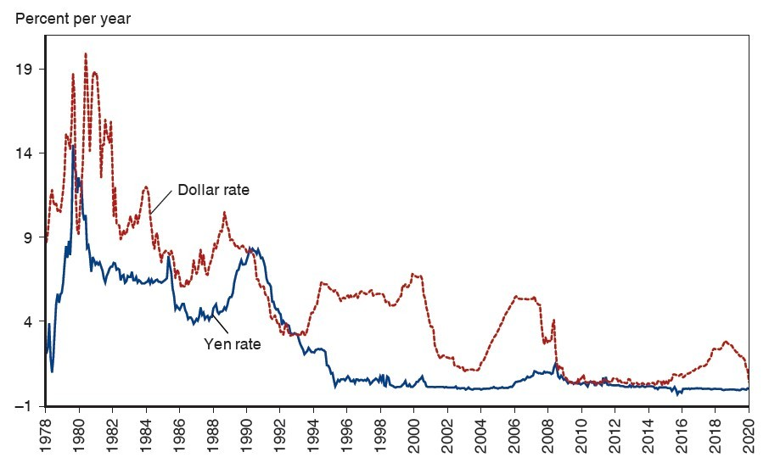
Answer: Since the dollar and the Yen interest rates are not measured in comparable terms, they can move quite differently over time. Except for a period from 1990 to 1993 when the Yen interest rate was higher than the dollar and the period between 2009 and 2011 when the interest rates were pretty close, dollar interest rates have been higher than the Yen, indicating depreciation of the dollar against the Yen.
Difficulty: Moderate
AACSB: Application of knowledge

16) What is the expected dollar rate of return on euro deposits if today's exchange rate is $1.10 per euro, next year's expected exchange rate is $1.20 per euro, the dollar interest rate is 10%, and the euro interest rate is 5%?
A) Calculate the expected dollar rate of return on euro deposits.
B) Given the result above, if you were an investor, would you hold wealth in the form of euro or dollar deposits? Explain why.
Answer: A) If today's exchange rate is $1.10 per euro, the dollar price of a euro is $1.10
If you purchase 1 euro deposit today, with interest rate of 5% a year, your deposit will be worth 1.05 euro at the end of the year.
Since the dollar is expected to depreciate against the euro over the coming year, the exchange rate 12 months from today is $1.20 per euro, you expect the dollar value of your euro deposit after a year to be $1.05 Euro x $1.20 per euro = $1.26
After you know the dollar price of 1 euro deport today ($1.10) and can forecast its value in a year ($1.26), you can calculate the expected dollar rate of return on a euro deposit as ($1.26-$1.10)/$1.10 = 0.15 or 15% a year.
B) Since the dollar interest rate is only 10% per year and the expected rate of return on a euro deposits is 15% per year, you expect to do better by holding your wealth in the form of euro deposits. Despite the fact that dollar interest rate exceeds the euro interest rate by 5% a year, the euro's expected appreciation against the dollar gives euro holders a prospective capital gain that is large enough to make the euro deposits the higher-yield asset.
Difficulty: Difficult
AACSB: Application of knowledge

17) For the following 15 cases, compare the dollar rates of return on dollar and euro deposits.

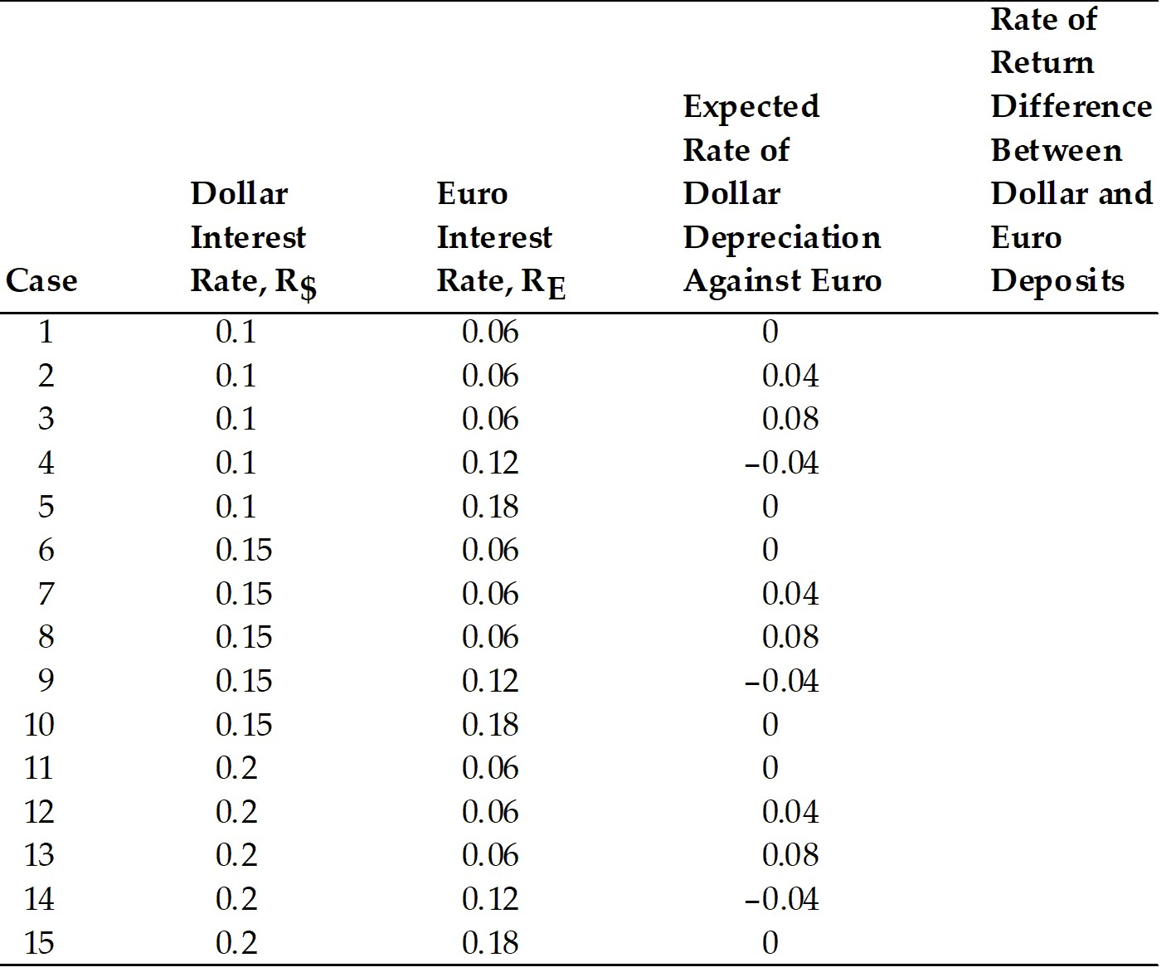
Answer:
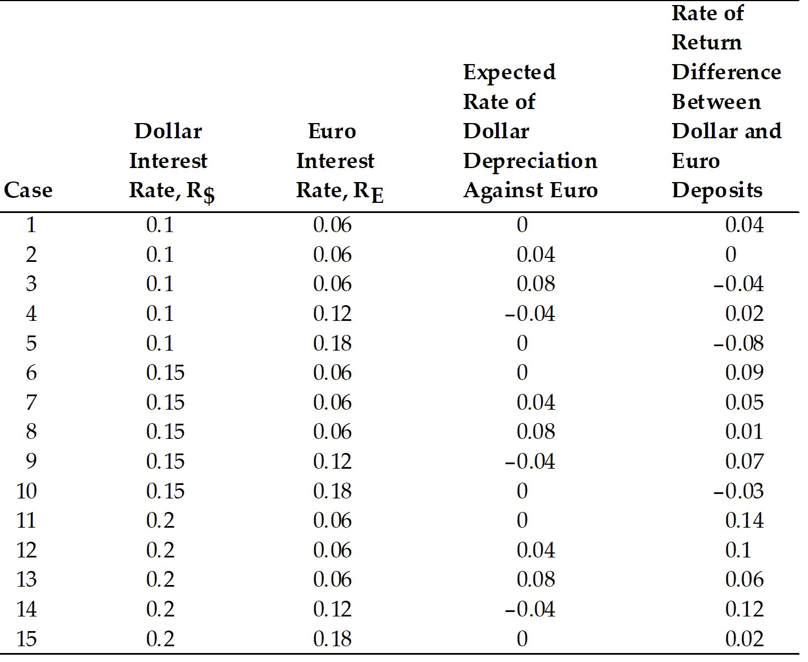
Difficulty: Moderate
AACSB: Application of knowledge

18) For the table below calculate the EXACT relationship (i.e., EXACT calculated result of the rate of return difference between dollar and euro deposits, up to 4 digits after the decimal point).

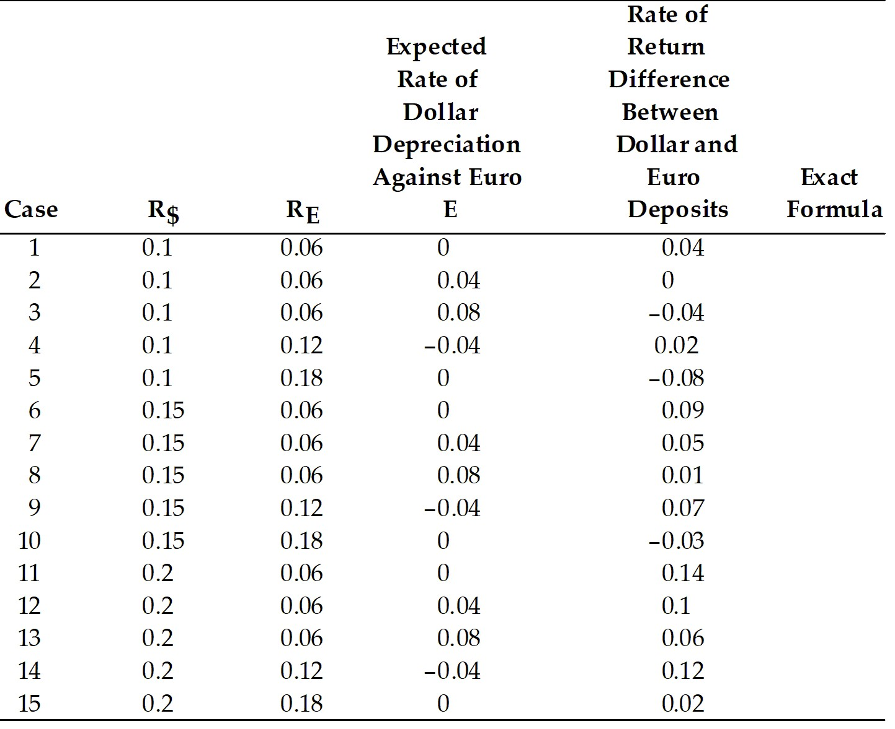

Answer: Using Figure (14-1) and Table 14-3 from the textbook as example, students can calculate the rate of return difference between dollar and euro deposits with up to 4 digits after the decimal point.
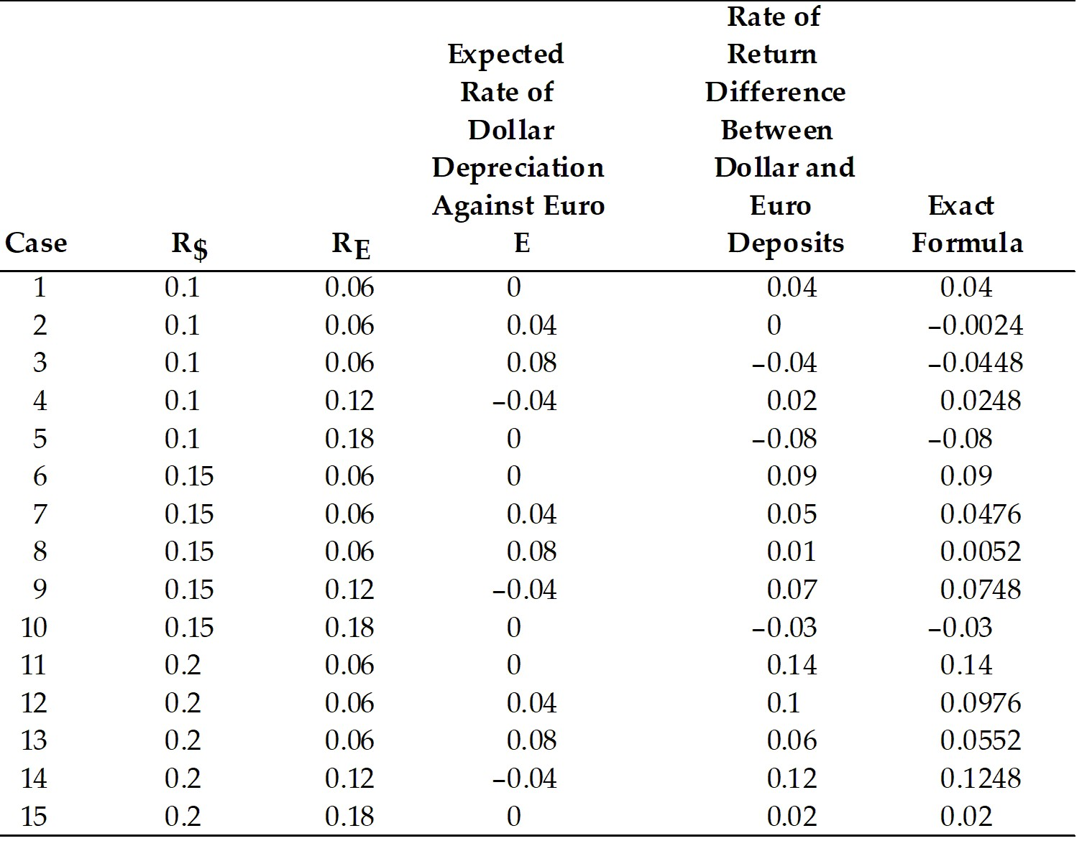

Difficulty: Moderate
AACSB: Application of knowledge

14.4 Equilibrium in the Foreign Exchange Market

1) Which one of the following statements is the MOST accurate?
A) A rise in the interest rate offered by dollar deposits causes the dollar to appreciate.
B) A rise in the interest rate offered by dollar deposits causes the dollar to depreciate.
C) A rise in the interest rate offered by dollar deposits does not affect the U.S. dollar.
D) For a given euro interest rate and constant expected exchange rate, a rise in the interest rate offered by dollar deposits causes the dollar to appreciate.
E) A rise in the interest rate offered by the dollar causes the euro to appreciate.
Answer: D
Difficulty: Easy
AACSB: Application of knowledge

2) Which one of the following statements is the MOST accurate?
A) For a fixed interest rate, a rise in the expected future exchange rate causes a rise in the current exchange rate.
B) For a fixed interest rate, a rise in the expected future exchange rate causes a fall in the current exchange rate.
C) For a fixed interest rate, a rise in the expected future exchange rate does not cause a change in the current exchange rate.
D) For a given dollar interest rate and a constant expected exchange rate, a rise in the interest rate of the euro causes the dollar to depreciate.
E) For a fixed interest rate, a fall in the expected future exchange rate causes a rise in the current exchange rate.
Answer: A
Difficulty: Easy
AACSB: Application of knowledge

3) A carry trade can be defined as
A) a trading strategy that involves borrowing low-interest currencies and buying high-interest currencies.
B) a trading strategy that involves borrowing high-interest currencies and buying low-interest currencies.
C) a trading strategy that involves borrowing and investing in only low-interest currencies.
D) a trading strategy that involves borrowing and investing in only high-interest currencies.
Answer: A
Difficulty: Easy
AACSB: Application of knowledge

4) A trade activity where international investors borrow low interest currencies and invest in high-interest currencies to seek profits is called
A) carry trade.
B) surplus trade.
C) deficit trade.
D) terms of trade.
Answer: A
Difficulty: Easy
AACSB: Application of knowledge

5) In a carry trade, the low interest currencies are called ________ currencies, and the high-interest currencies are called ________ currencies.
A) funding; investment
B) borrowing; lending
C) lending; borrowing
D) investment; funding
Answer: A
Difficulty: Easy
AACSB: Application of knowledge

6) What is the interest parity condition?
Answer: The condition that the expected returns on deposits of any two currencies are equal when measured in the same currency is called the interest parity condition. It implies that potential holders of foreign currency deposits view them as equally desirable assets, i.e. risk is assumed away.
In notational forms:
R$ = RE + (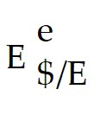 - E$/E)/E$/E
Difficulty: Easy
AACSB: Application of knowledge

7) Explain why the interest parity condition must hold if the foreign exchange market is in equilibrium.
Answer: The foreign exchange market is in equilibrium when deposits of all currencies offer the same expected rate of return. Potential holders of foreign currency deposits view them all as equally desirable assets. If expected rate of return on any currency deposit is higher or lower than the other, there will exist an excess supply or demand for that currency because one will yield a higher return than the other.
Difficulty: Moderate
AACSB: Application of knowledge

8) Calculate the interest rate in the United States, if interest parity condition holds, for the following 15 cases.

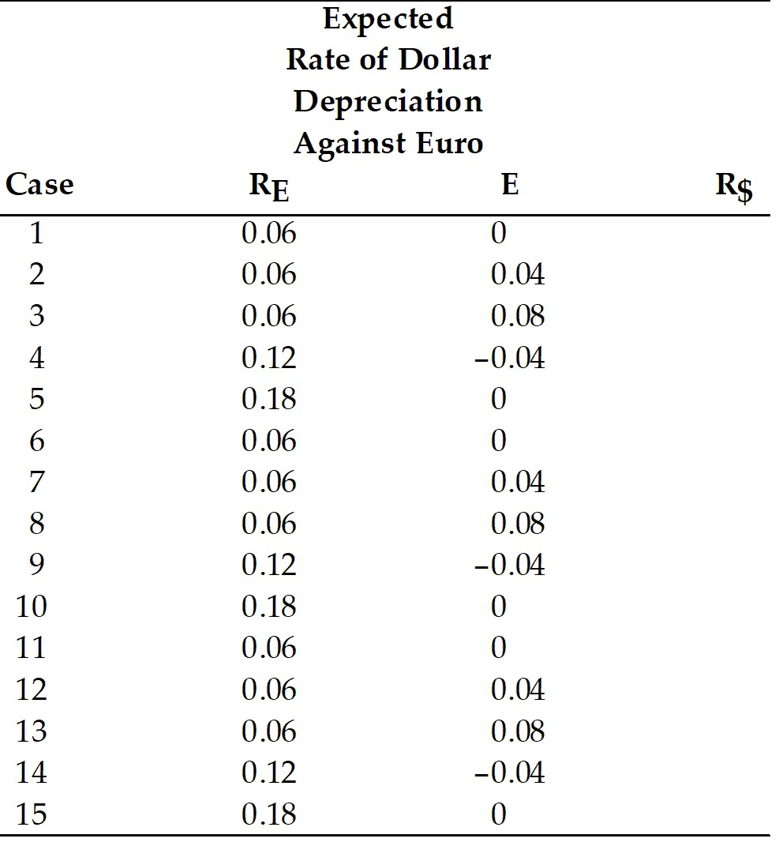

Answer:
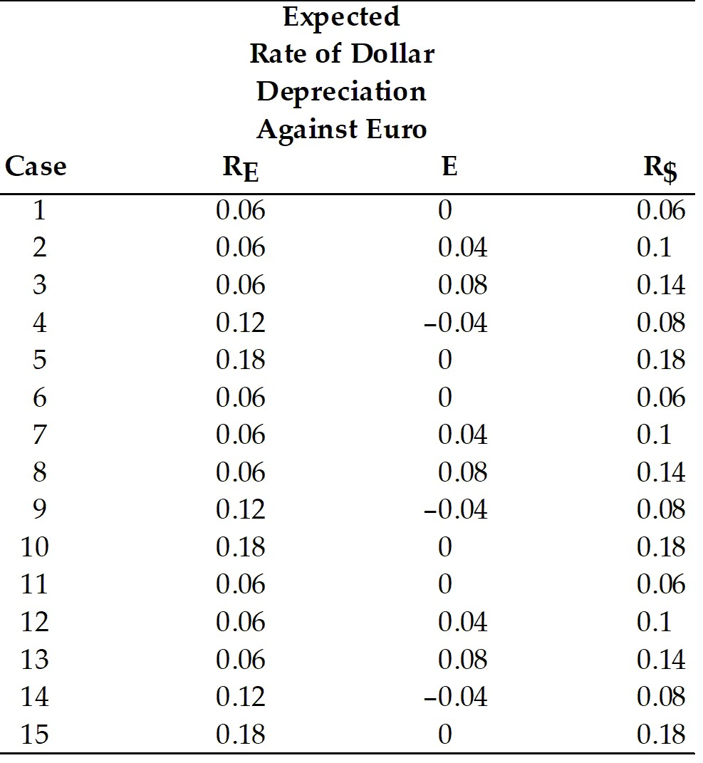

Difficulty: Moderate
AACSB: Application of knowledge

9) Calculate the interest rate in the euro zone if interest parity condition holds, for the following 15 cases.

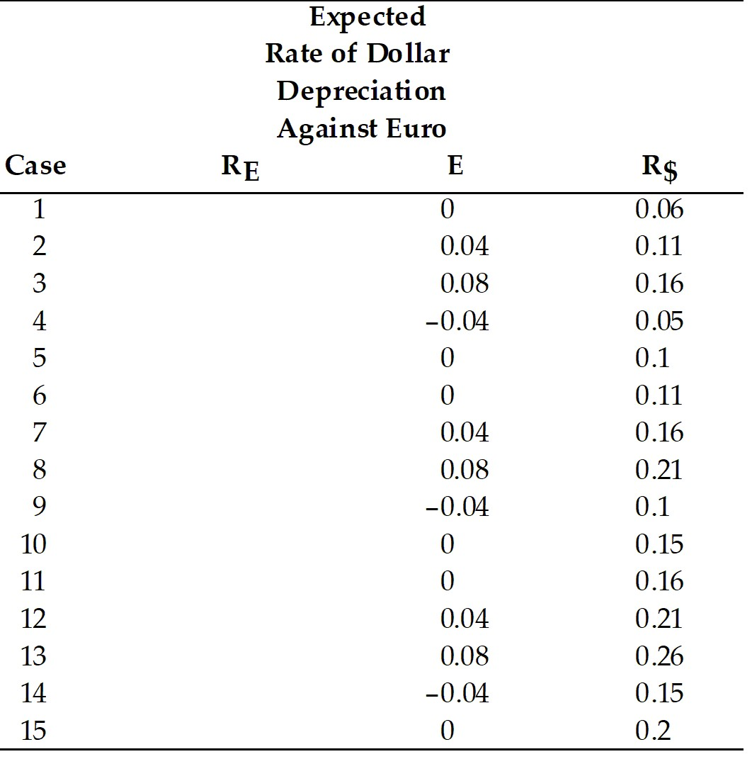
Answer:
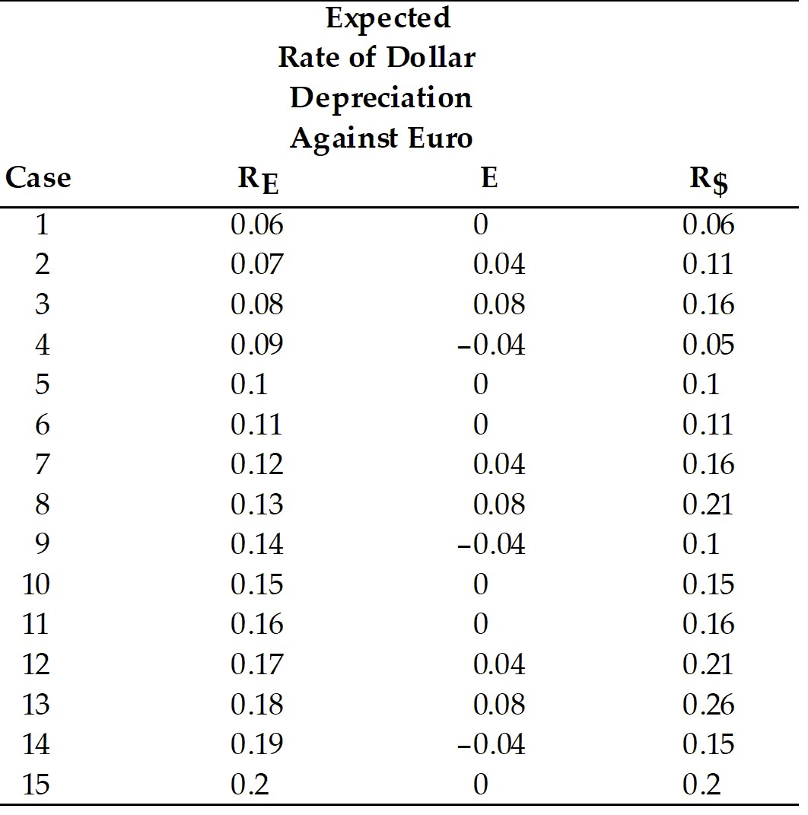
Difficulty: Moderate
AACSB: Application of knowledge

10) Determine for each, whether the interest parity condition holds or not, if 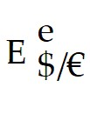 = 1.10

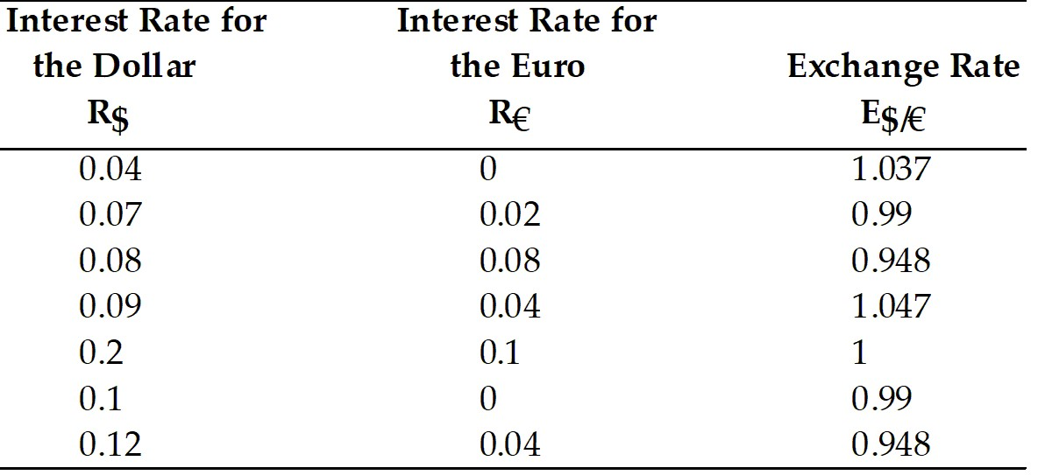

Answer:
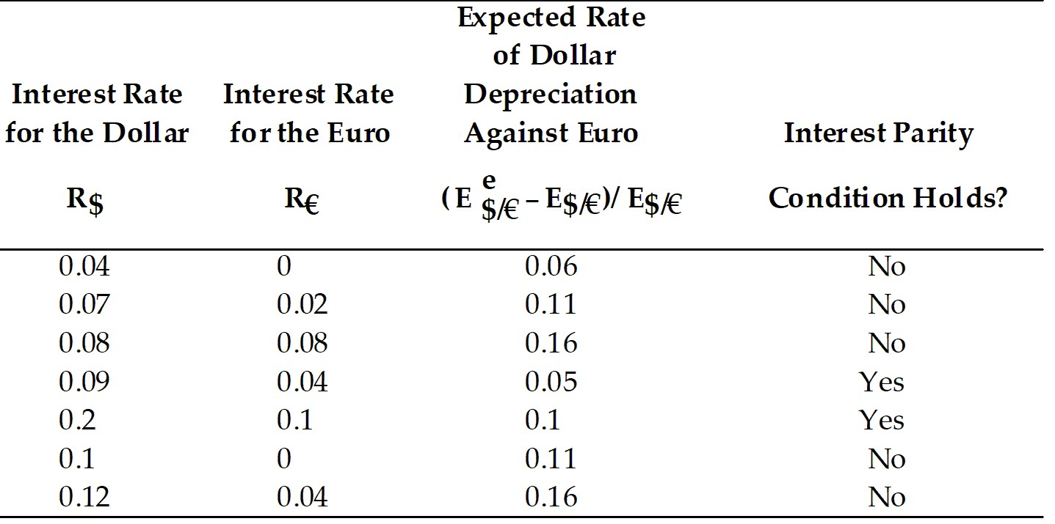

Difficulty: Moderate
AACSB: Application of knowledge

11) Assume that the euro interest rate is constant at 5 percent, and that the expected exchange rate is 1.05 dollars per one euro. Find the expected dollar return on euro deposits for the following cases.

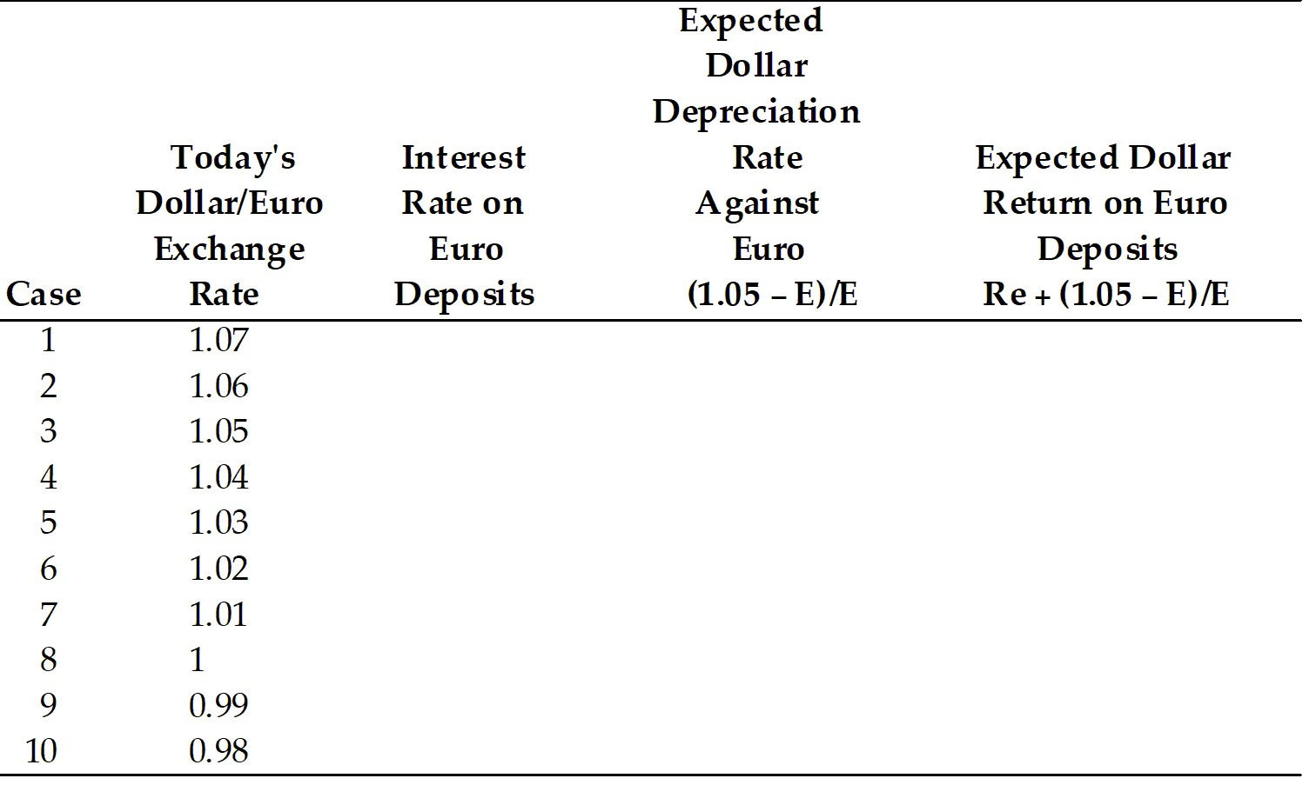

Answer:
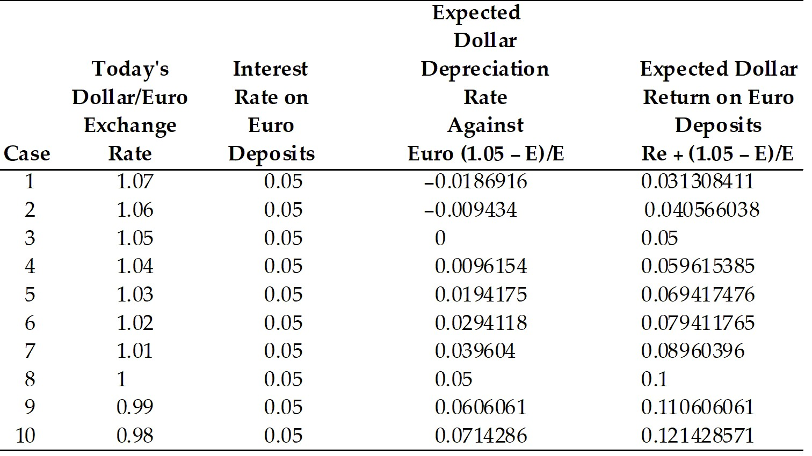

Difficulty: Moderate
AACSB: Application of knowledge

12) Using the data in the table above, plot today's dollar/euro exchange rate against the expected dollar return on euro deposits.
Answer:
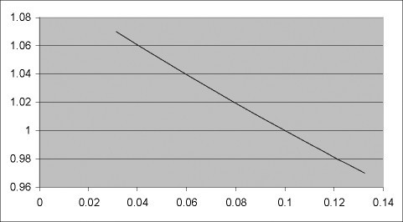
Difficulty: Moderate
AACSB: Application of knowledge

13) Calculate the Expected Dollar Depreciation Rate against the euro and the expected dollar return on euro deposits if the expected exchange rate is $1.10 per euro.

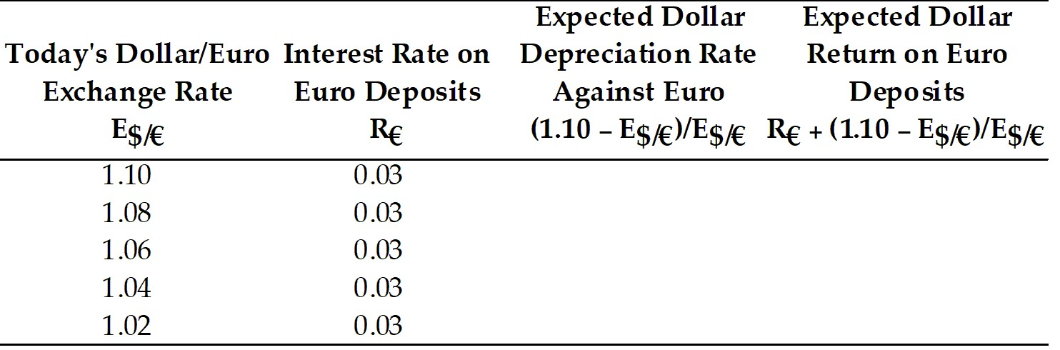

Answer:
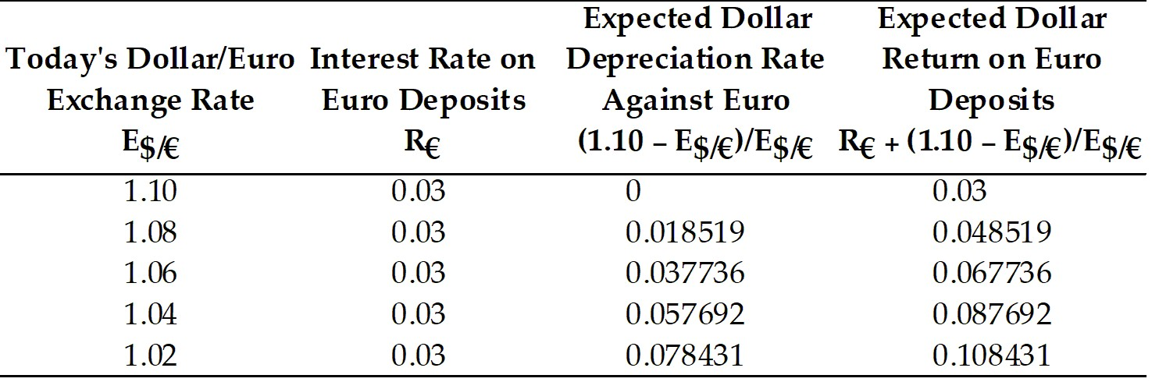

Difficulty: Moderate
AACSB: Application of knowledge

14) Discuss the effects of a rise in the dollar interest rate on the exchange rate.
Answer: There are two effects to consider. A rise in the interest rate offered by dollar deposits combined with a constant expected exchange rate will cause the dollar to appreciate (see Figure 14-5 from the text). However, the expected exchange rate will likely change. As Figure 14-6 from the text shows, if the expected exchange rate increases, the dollar will depreciate.

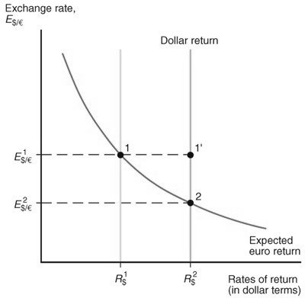
Figure 14-5

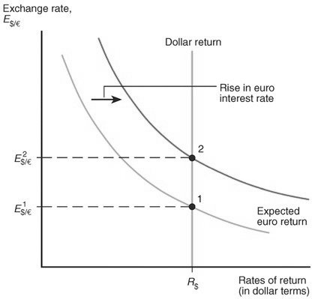
Figure 14-6
Difficulty: Moderate
AACSB: Application of knowledge

15) Discuss the effects of a rise in the interest rate paid by euro deposits on the exchange rate.
Answer: There are two effects to consider. If we make the unrealistic assumption that the expected exchange rate will not change, then a rise in the interest rate paid by euro deposits causes the dollar to depreciate. However, if the expected exchange rate were to rise, then the current exchange rate would also rise. (See Figure 14-6 from the text.)



Difficulty: Moderate
AACSB: Application of knowledge

16) Explain why (holding interest rates constant), a rise in the expected depreciation in a country's currency leads to depreciation of that currency today.
Answer: A rise in the expected depreciation rate of the dollar raises the expected dollar return on euro deposits. Now, there are excess supply of dollar deposits (euro deposits offer higher expected rate of return than do dollar deposits). The dollar must depreciate to remove this excess supply.
Difficulty: Moderate
AACSB: Application of knowledge

17) Show graphically a drop in the interest rate paid by euro deposits. What is the effect on the dollar?
Answer: A drop in the interest rate from R1$ to R2$ causes the dollar to depreciate from 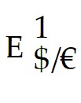 (point 2) to 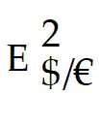 (point 1). (See Figure 14-5 from the text.)

Difficulty: Difficult
AACSB: Application of knowledge

18) Show graphically a drop in the interest rate offered by dollar deposits, R$, and the effect on the exchange rate, 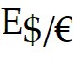.
Answer: A drop in the interest rate paid by euro deposits causes the dollar to appreciate from  (point 2) to  (point 1). The expected future exchange rate also drops. (See Figure 14-6 from the text.)


Difficulty: Difficult
AACSB: Application of knowledge

19) What is a carry trade?
Answer: A carry trade is a trading strategy that involves borrowing a currency that has a low interest rate, then use that money to buy another currency that pays a higher interest rate. low-interest currencies and re-investing in high-interest currencies. A carry trader may gain profits on the difference between the interest rates.
Difficulty: Easy
AACSB: Application of knowledge

20) Explain why carry trade should not be systematically profitable and is a highly risky business.
Answer: Carry trade involves high risks and liquidity factors. Investment currencies (the high-interest currencies that carry traders target) may experience abrupt crashes and funding currencies (the low interest currencies that carry traders borrow) may be subject to abrupt appreciation. Big carry trade positions emergence can result in great exchange volatility as well as the possibility of big trader losses with negative repercussions in stock markets, bond markets, and markets for interbank loans.
Difficulty: Moderate
AACSB: Application of knowledge

14.5 Forward Exchange Rates and Covered Interest Parity

1) The covered interest rate parity condition can be stated as follows: The interest rate on dollar deposits equals the interest rate on euro deposits ________ the forward ________ on euros against dollars.
A) plus; premium
B) minus; premium
C) plus; discount
D) minus; discount
E) times; premium
Answer: A
Difficulty: Easy
AACSB: Application of knowledge

2) The covered interest rate parity condition can be stated as follows: The interest rate on dollar deposits equals the interest rate on euro deposits ________ the forward ________ on dollars against euros.
A) plus; premium
B) plus; discount
C) times; premium
D) minus; premium
E) minus; discount
Answer: B
Difficulty: Easy
AACSB: Application of knowledge

3) Suppose that the one-year forward price of euros in terms of dollars is equal to $1.113 per euro. Further, assume that the spot exchange rate is $1.05 per euro, and the interest rate on dollar deposits is 10 percent and on euro it is 4 percent. Under these assumptions
A) covered interest parity does hold.
B) covered interest parity does not hold.
C) it is hard to tell whether covered interest parity does or does not hold.
D) covered interest parity fluctuates.
E) Not enough information is given to answer the question.
Answer: B
Difficulty: Moderate
AACSB: Application of knowledge
4) Assume the U.S. interest rate is 10 percent, and the interest rate on euro deposits is 5 percent. For the following exchange rates, find the forward exchange rates.

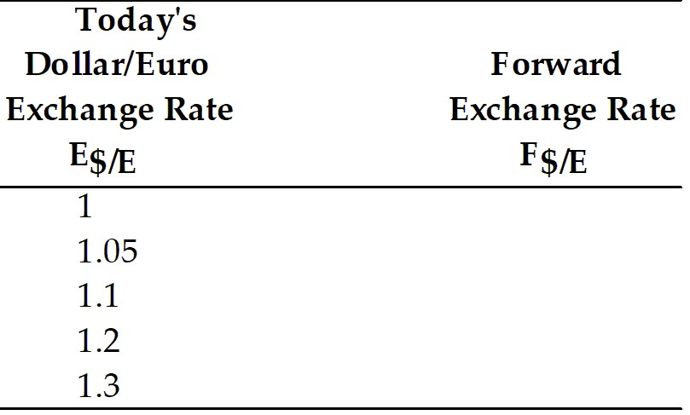

Answer: Using the covered interest rate parity will yield the second column in the table:

F$/E = (R$ - RE) E$/E + E$/E

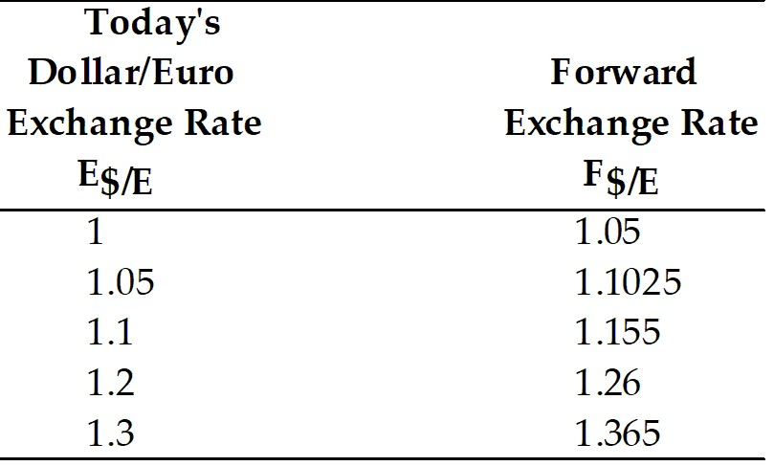

Difficulty: Moderate
AACSB: Application of knowledge

